

SOFTWARE-REQUIREMENT-DOCUMENT

Coffee Shop :



**Prepared for:**

Dr. Mohamad Ali Nader

Prepared by:

**Zahraa Abdel Hassan**

**Rwane Dbouk**

**Batoul Yassin**

**Signature:**

[**zba096@usal.edu.lb**](mailto:zba096@usal.edu.lb)

Table of Contents

SDLC Model Chosen: 4

❖ Feasibility Study for the Patient Management System: 4

Technical Feasibility: 5

Operational Feasibility: 5

Legal Feasibility: 5

Scheduling Feasibility: 5

The online shop accepts all orders from 7 am to 10 pm. 5

Economic Feasibility: 5

Introduction 7

1.1 Product scope 7

1.2 Product Value 7

1.3 Intended audience 7

1.4 Intended use 8

1.5 General description 8

Functional requirements 9

Functional Requirements: 9

1. User Authentication: 9

2. Menu Display: 9

3. Online Ordering System: 9

4. Order Management: 9

5. Location Information: 9

6. Operating Hours: 9

Graphics Requirements: 9

Logo and Branding: 10

Image Optimization: 10

Operating System Requirements: 11

Cross-Browser Compatibility: 11

Constraints: 11

1. Data Privacy and Security: 11

2. Responsive Design: 11

3. Technology Stack: 11

External interface requirements 12

3.1 User interface requirements 12

3.1.1 Point of Sale (POS) System 12

3.1.2 Menu Display 12

3.1.3 Order Tracking 12

3.1.4 Customer Accounts 12

3.2 Hardware interface requirements 13

3.2.1 Point of Sale Terminal 13

3.2.2 Kitchen Display System 13

3.2.3 Mobile Devices 13

3.3 Software interface requirements 14

3.3.1 Database Management 14

3.3.2 Payment Gateway 14

3.3.3 Inventory Management 14

3.4 Communication interface requirements 15

3.4.1 SMS Notifications: 15

3.4.2 chat box 15

3.4.3 Email Notifications 15

Non-functional requirements 16

4.1 Security 16

4.1.1 Data Encryption 16

4.1.2 Access Control 16

4.1.3 Authentication 16

4.1.4 Audit Trail 16

4.2 Capacity 16

4.2.1 Concurrent Users 16

4.2.2 Transaction Throughput 16

4.3 Compatibility 16

4.2.1 Concurrent Users 16

4.2.2 Transaction Throughput 16

4.4 Reliability 17

4.4.1 System Uptime 17

4.4.2 Fault Tolerance 17

4.5 Scalability 17

4.5.1 Vertical Scalability 17

4.5.2 Horizontal Scalability 17

4.6 Maintainability 17

4.6.1 Code Maintainability 17

4.6.2 Upgrades and Patches 17

4.7 Usability 18

4.7.1 Accessibility 18

4.7.2 Training Requirements 18

4.8 Other 18

4.8.1Performance Monitoring 18

Phase2: 19

------- 19

**1)UseCase Diagram:** 19

**2)Activity diagram:** 20

**3)Class Diagram:** 21

Phase4: 23

------ 23

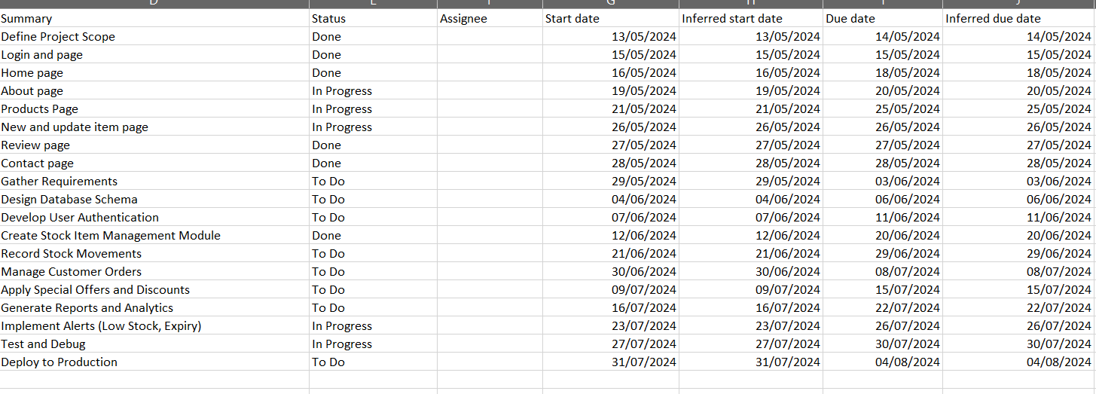 23

Grant Char: 24

2)Pert Chart: 25

# SDLC Model Chosen:

We use the waterfall model, which is the basic SDLC model it is simple but romantic:

**Easy to Understand:** The waterfall model is like following a recipe step-by-step.

**Suitability**: This model is well-suited for projects where requirements are well-understood.

**Risk management:** The waterfall model allows for the identification of risks early in the project.

**Documentation:** The waterfall model emphasizes documentation at each stage of development including requirements, design specifications, and test plans.

**Predictability:** Since this model follows a linear sequential approach it makes it easier to predict timelines and budget requirements for the project.

## Feasibility Study :

Explanation of the purpose and scope of the feasibility study:

### Technical Feasibility:

Assess the availability and suitability of the location for a coffee shop.

Evaluate the infrastructure requirements, such as electricity, water, and ventilation systems.

Determine the feasibility of installing and maintaining necessary equipment and technology.

### Operational Feasibility:

Evaluate the availability of skilled personnel.

Assess the sourcing of high-quality coffee ingredients.

Determine the efficiency of the workflow and operational processes including order-taking, preparation, and customer service.

### Legal Feasibility:

This website is legal and follows all conditions...According to the copyright and other conditions.

### Scheduling Feasibility:

### The online shop accepts all orders from 7 am to 10 pm.



1

# Introduction

The purpose of this Software Requirements Specification (SRS) document is to outline the requirements and specifications for the development of a Coffee Shop Website. This document serves as a comprehensive guide for the development team, stakeholders, and other involved parties to ensure a clear understanding of the project's scope and objectives.

* 1. Product scope

The Coffee Shop Website aims to provide an online platform that enables customers to seamlessly explore the coffee shop's offerings, place orders, and obtain information about the shop's location and operating hours. The product's objectives include enhancing customer experience, increasing online visibility, and streamlining order management for improved efficiency. The scope encompasses a user-friendly website with features for menu browsing, online ordering, and interactive engagement.

* 1. Product Value

Audiences, including coffee enthusiasts and potential customers, will find value in the product through its convenience and accessibility.

The website offers customers the ability to explore the menu at their leisure, place orders from the comfort of their homes, and stay informed about the coffee shop's latest offerings. The product adds value by bridging the gap between the physical and digital realms, providing a modern and efficient way for customers to interact with the coffee shop.

* 1. Intended audience

The product is intended to serve a diverse audience, including customers, coffee enthusiasts, and the coffee shop staff. Customers seek a convenient and enjoyable online ordering experience. Coffee shop staff will use the platform to manage orders and update website content.

* 1. Intended use

The intended audience will use the product to explore the coffee shop's menu, place online orders, and access information about the coffee shop's location and operating hours. Customers can personalize their orders, track deliveries, and engage with the coffee shop digitally. The coffee shop staff will utilize the platform to manage incoming orders, update the menu, and communicate relevant information.

* 1. General description

The software will perform functions such as displaying the menu, processing online orders, providing order status updates, and offering information about the coffee shop's location and hours. Features include an intuitive user interface, secure payment processing, and interactive elements to enhance customer engagement. The website aims to create a seamless and enjoyable experience for customers interacting with the coffee shop online.

# Functional requirements



2

## Functional Requirements:

### 1. User Authentication:

- Design Requirement: Our soft is a secure user authentication system, allowing customers to create accounts and log in.

- Constraint: Passwords must meet security standards, and account information should be stored securely.

### 2. Menu Display:

- Design Requirement: Design an intuitive and visually appealing menu display that showcases coffee offerings with detailed descriptions.

- Graphics Requirement: High-quality images of each menu item to enhance visual appeal, and in addition the image should be available with no copyright.

### 3. Online Ordering System:

- Allow authentication users to order easily.

### 4. Order Management:

- Design Requirement: Create an administrative dashboard.

- Constraint: Real-time synchronization between the online platform and the coffee shop's point-of-sale system.

### 5. Location Information:

- Design Requirement: Include a map interface displaying the coffee shop's location and additional contact details.

- Constraint: Integrate with a reliable mapping service to provide accurate location information.

### 6. Operating Hours:

- Design Requirement: Display the coffee shop's operating hours prominently on the website.

- Constraint: Update operating hours dynamically for holidays or special events.

## Graphics Requirements:

### Logo and Branding:

- Design Requirement: Develop a visually appealing logo and incorporate consistent branding elements throughout the website.

- Constraint: Ensure all graphics align with the coffee shop's brand guidelines.

### Image Optimization:

- Design Requirement: Optimize all images for web usage to maintain fast loading times.

- Constraint: Images should not compromise the website's performance.

## Operating System Requirements:

### Cross-Browser Compatibility:

- Design Requirement: Ensure compatibility with major web browsers such as Chrome, Firefox, Safari, and Edge.

- Constraint: Regularly test and update compatibility as new browser versions are released.

## Constraints:

### 1. Data Privacy and Security:

- Constraint: Adhere to data protection regulations and implement robust security measures to protect customer information.

### 2. Responsive Design:

- Constraint: Ensure the website is responsive, providing a seamless experience across various devices (desktops, tablets, smartphones).

### 3. Technology Stack:

- Constraint: Specify the technology stack to be used, considering the coffee shop's existing infrastructure and budget constraints.

# External interface requirements



3

* 1. User interface requirements

### 3.1.1 Point of Sale (POS) System

- The system shall provide an intuitive and user-friendly interface for processing customer orders.

- The POS interface should include options for adding, modifying, and removing items from the order.

- The user interface must support various payment methods, including cash, credit cards, and mobile payments.

### 3.1.2 Menu Display

- The software shall display the coffee shop menu in a clear and visually appealing manner.

- The menu should be easily navigable, with categories for different types of beverages, snacks, and specials.

### 3.1.3 Order Tracking

- The system must have a real-time order tracking feature for both customers and staff.

- Staff members should be able to view and manage orders easily, updating the status as they progress (e.g., preparing, ready for pickup).

### 3.1.4 Customer Accounts

- Customers should have the option to create accounts for personalized experiences.

- The system shall store order history, allowing customers to reorder their favorite items quickly.

* 1. Hardware interface requirements

### 3.2.1 Point of Sale Terminal

- The software must be compatible with standard Point of Sale terminals commonly used in coffee shops.

- It should support peripherals such as barcode scanners, receipt printers, and card readers.

### 3.2.2 Kitchen Display System

- The software should interface with a Kitchen Display System for efficient order management in the kitchen.

- Integration with kitchen hardware such as printers and monitors is required.

### 3.2.3 Mobile Devices

- The system should be accessible on mobile devices (tablets and smartphones) for order taking and processing.

* 1. Software interface requirements

### 3.3.1 Database Management

- The software shall integrate with a secure and scalable database for storing customer information, menu items, and order details.

- Compatibility with popular database management systems (e.g., MySQL, PostgreSQL) should be ensured.

### 3.3.2 Payment Gateway

- Integration with a reliable payment gateway is necessary for processing electronic payments securely.

- The software should support multiple payment gateways to accommodate various customer preferences.

### 3.3.3 Inventory Management

- The system must interface with an inventory management system to track stock levels and automatically update the menu.

* 1. Communication interface requirements

### 3.4.1 SMS Notifications:

* - Optionally, the system may support SMS notifications for critical alerts such as low stock levels, order status updates, and urgent messages.

### 3.4.2 chat box

- The system must facilitate real-time communication between different components, such as order updates between the POS and the kitchen.

### 3.4.3 Email Notifications

- Implement push notifications or email alerts to inform customers and staff about order status changes and promotions.

# Non-functional requirements



4

* 1. Security

### 4.1.1 Data Encryption

All sensitive data must be encrypted during transmission and storage does not work.

### 4.1.2 Access Control

Role-based access control (RBAC) should be implemented to restrict system access based on user roles (e.g., cashier, manager).

### 4.1.3 Authentication

The system does not support all authentication methods.

### 4.1.4 Audit Trail

A comprehensive audit trail should be maintained, but it does not work well, logging all user activities and system changes for security and compliance purposes.

* 1. Capacity

### 4.2.1 Concurrent Users

The system must support a specified number of concurrent users during peak hours, ensuring efficient order processing and minimal downtime.

### 4.2.2 Transaction Throughput

Define the maximum number of transactions per second (TPS) the system should handle without performance degradation.

* 1. Compatibility

### 4.2.1 Concurrent Users

The system must support a specified number of concurrent users during peak hours, ensuring efficient order processing and minimal downtime.

### 4.2.2 Transaction Throughput

Define the maximum number of transactions per second (TPS) the system should handle without performance degradation.

* 1. Reliability

### 4.4.1 System Uptime

Define the acceptable system uptime, ensuring that the software is available for use during specified business hours.

### 4.4.2 Fault Tolerance

The system should gracefully handle failures and recover without data loss or significant disruption to service.

* 1. Scalability

### 4.5.1 Vertical Scalability

The system should be able to scale vertically to handle increased loads by upgrading hardware resources.

### 4.5.2 Horizontal Scalability

Implement mechanisms for horizontal scalability, allowing the system to scale by adding more servers or instances.

* 1. Maintainability

### 4.6.1 Code Maintainability

Enforce coding standards and documentation practices to ensure the software's long-term maintainability.

### 4.6.2 Upgrades and Patches

Provide a seamless process for applying software updates, patches, and new releases to ensure the system stays current.

* 1. Usability

### 4.7.1 Accessibility

The user interface should adhere to accessibility standards, making it usable for individuals with disabilities.

### 4.7.2 Training Requirements

Ensure that the system requires minimal training for staff to use effectively, promoting efficient operations.

* 1. Other

### 4.8.1Performance Monitoring

Implement tools and mechanisms for continuous performance monitoring to identify and address potential issues proactively.

# Phase2:

# -------

## **1)UseCase Diagram:**

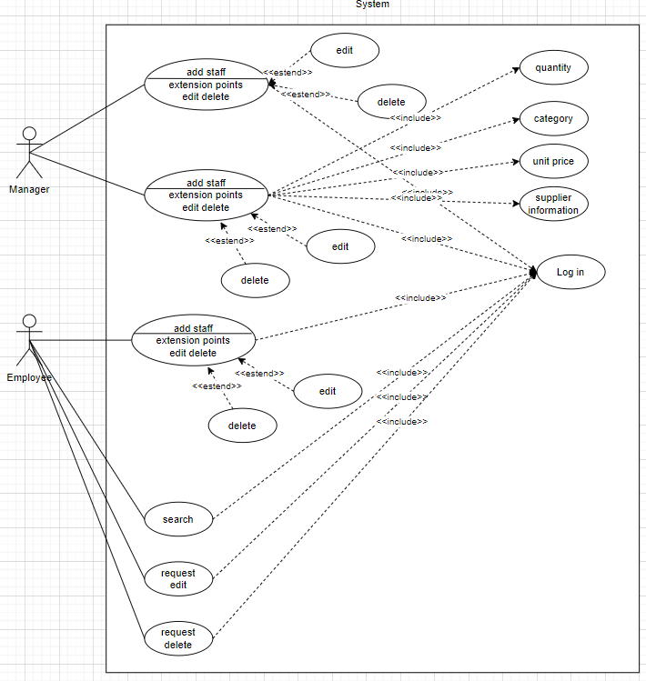

## **2)Activity diagram:**

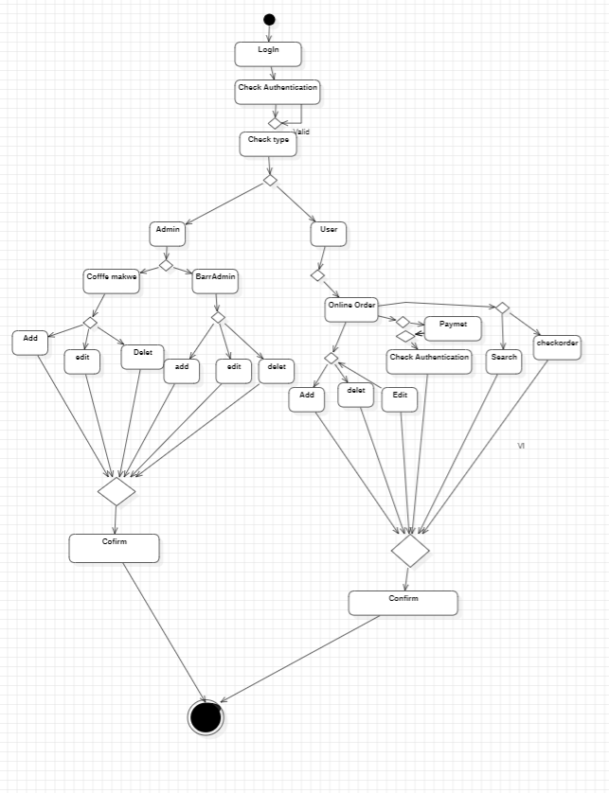

## **3)Class Diagram:**

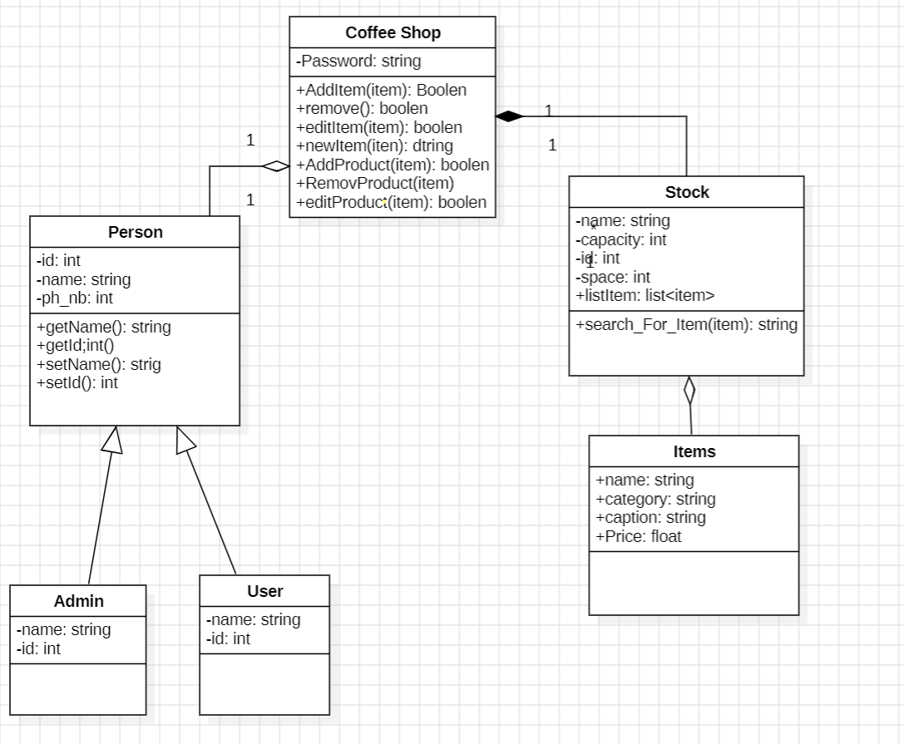

4)Data flow diagram:

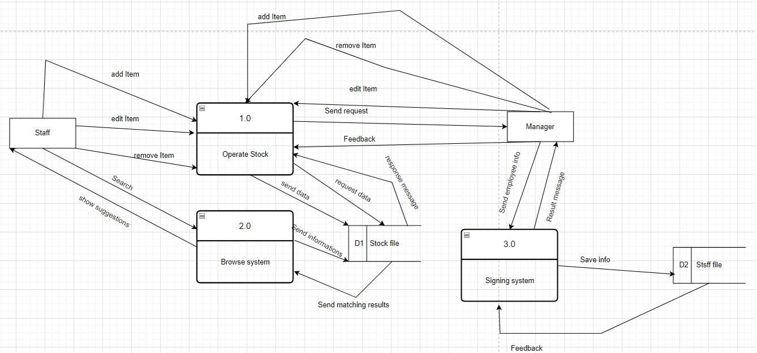

# Phase4:

# ------

|  |  |  |
| --- | --- | --- |
| Task | Duration | Reference |
| Define Project Scope | 2 days | 1 |
| Login and page | 1 day | 2 |
| Home page | 3 days | 3 |
| About page | 2 days | 4 |
| Products Page | 5days | 5 |
| New and updated item page | 1 day | 6 |
| Review page | 1 day | 7 |
| Contact page | 1day | 8 |
| Gather Requirements | 6 days | 9 |
| Design Database Schema | 3 days | 10 |
| Develop User Authentication | 5 days | 11 |
| Create a Stock Item Management Module | 9 days | 13 |
| Record Stock Movements | 9 days | 14 |
| Manage Customer Orders | 9 days | 15 |
| Apply Special Offers and Discounts | 7 days | 16 |
| Generate Reports and Analytics | 7 days | 17 |
| Implement Alerts (Low Stock, Expiry) | 4 days | 18 |
| Test and Debug | 4 days | 19 |
| Deploy to Production | 4 days | 20 |
|  |  |  |

# 

# Gant Char:

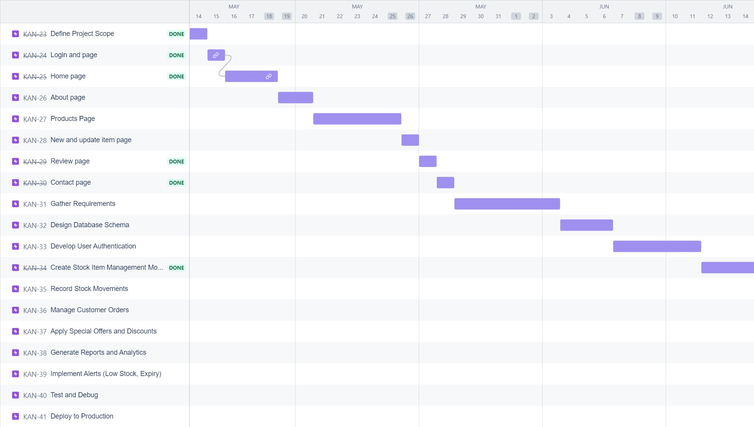

# 2)Pert Chart:

Product Page

Add Item

LogIn Page

1 Day 2 day 3 days

Admin Page

Add Section

Add employee

SignUp Page

2 days

2 days

1 day 4 days

Sell Products

Decision page

View Page

Notification page

3 days

Definitions and acronyms



5

|  |  |
| --- | --- |
| POS | Point of Sale |
| API | Application Programming Interface |
| RBAC | Role-Based Access Control |
| TPS | Transactions Per Second |